***PAAREES PERFUMES***

***CALVIN KLIEN***

***FOR WOMEN***

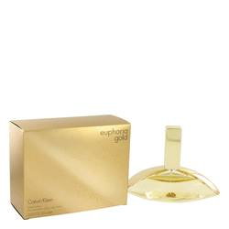

# 

***EUPHORIA GOLD***

## *Description:*

Euphoria Gold by Calvin Klein Perfume. Live every day in a state of fragrant euphoria and bliss when you spritz on Euphoria Gold for women. Designed by the iconic fashion house of Calvin Klein in 2014, this sensual scent is worth its weight in olfactory gold with its notes of juicy kumquat, tangerine and sweet apricot that mingle with garden-inspired hints of daffodil and sweet gardenia. Wear this nose-temptingly romantic scent whenever you want to feel elegant, affluent and powerfully evocative.